Software Requirement Specification (SRS)
Project name: Care Hub
Document: Version: 1.0
Date: 06/12/2024

Document History
Date | Author | Version | Description
06/12/2024 | Eric Afenyo | 1.0 | Initial

Table of Contents
1. Introduction 3
1.1. Purpose 3
1.2. Project Scope 3
1.3. Terminology 3
1.4. Operating Environment 3
2. Functional Requirements 3

Introduction

Purpose
This document outlines the software requirements for the Care Hub web application. It explains how the system works and how users interact with it.

Project Scope
Care Hub is a web application designed to improve patient care coordination. It includes features such as note-taking, appointment scheduling, medication tracking, task management, and patient vital signs monitoring. These features help caregivers, family, friends, and healthcare professionals work together more efficiently to support the patient's health.

Terminology
- Caregiver: Family members and friends assisting patients.
- Care Groups: A collaborative feature for sharing tasks and updates about patient care.
- Appointment Booking: Scheduling and managing medical and care-related visits.
- Healthcare Providers: Professionals responsible for managing patient care plans.

Operating Environment
- Platform: Web application compatible with major browsers.
- Hosting: Cloud-based infrastructure.
- Device Support: Devices with internet connectivity.

Functional Requirements

Use Cases

Use case diagram
A visual representation of the system's main actors and their interactions with the system.

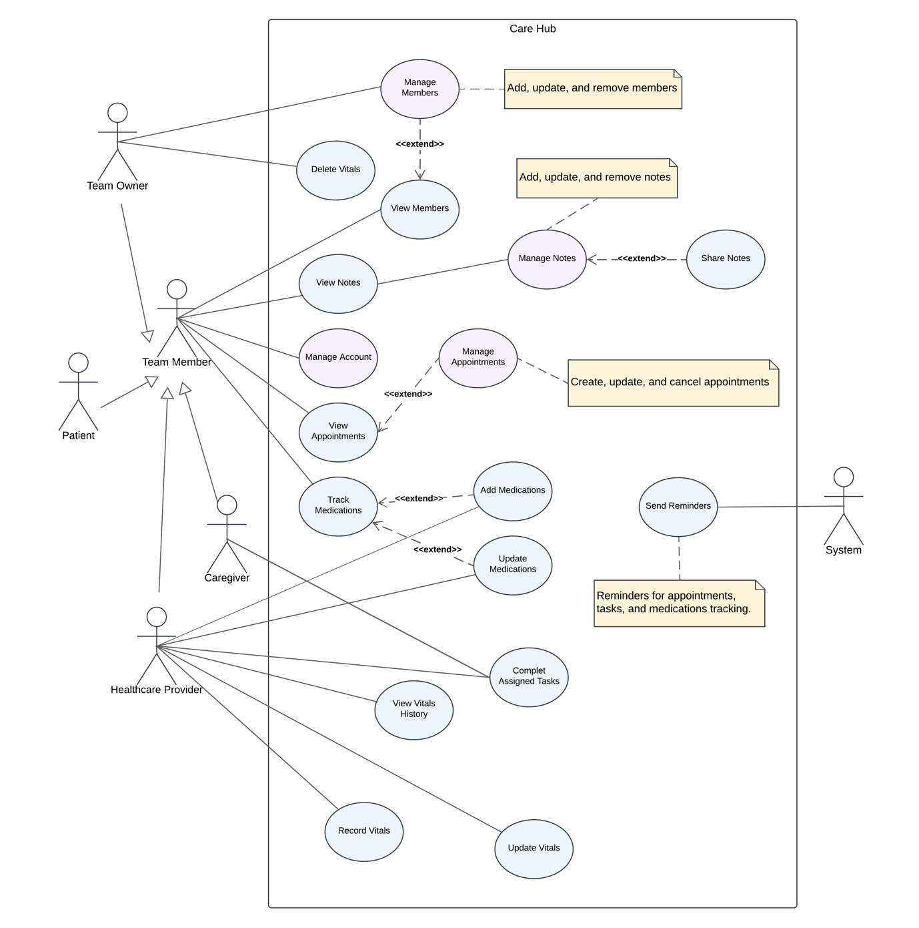

Use Case 1: Manage Account

Description
This use case enables users to access and manage their account information, including updating personal information, address details, and passwords.

Sub-Use Case 1.1: Access Profile

Description:
Allows users to navigate to the profile page via the avatar in the top navigation bar.

Access Rules:
- Authentication is required to access the profile.

Actions:
N | HTML Element | Action type | Result
1 | Avatar | Click | System displays a dropdown menu with the "Profile" option.
2 | "Profile" Option | Click | System displays the profile page.

Sub-Use Case 1.2: Update Personal Information

Description:
Allows users to update their personal information on the profile page.

Access Rules:
- Only authenticated users can edit their personal information.
Actions:
N | HTML Element | Action type | Result
1 | Input Fields | Typing | Personal details fields updated with new information.
2 | "Save Changes" Button | Click | Updated personal details are saved into the database. System displays a confirmation message.

Sub-Use Case 1.3: Update Address

Description:
This use case allows users to update their address information.

Access Rules:
- Only authenticated users can edit their address information.
Actions:
N | HTML Element | Action type | Result
1 | Input Fields | Typing | Address fields updated with new information.
2 | "Save Changes" Button | Click | Updated address details are saved into the database. System displays a confirmation message.

Sub-Use Case 1.4: Change Password

Description:
This use case allows users to update their account password securely.

Access Rules:
- Only authenticated users can change their password on the profile page.
Actions:
N | HTML Element | Action type | Result
1 | Input Fields | Typing | Password fields updated with new information.
2 | "Save Changes" Button | Click | Updated password details are saved into the database. System displays a confirmation message.

Sub-Use Case 1.5: Deactivate/Delete Account
Description:
This use case allows users to either deactivate or permanently delete their accounts.

Actions:
N | HTML Element | Action type | Result
1 | "Deactivate/ Delete Account" Button | Click | The system displayed a confirmation modal.
2 | "Confirm" Button | Click | Temporarily deactivates or permanently deletes the account and logs the user out.
 | "Cancel" Button | Click | The confirmation model is closed

Data Requirements

Entity-Relationship Diagram (ERD)
Diagram illustrating the relationships between major system entities
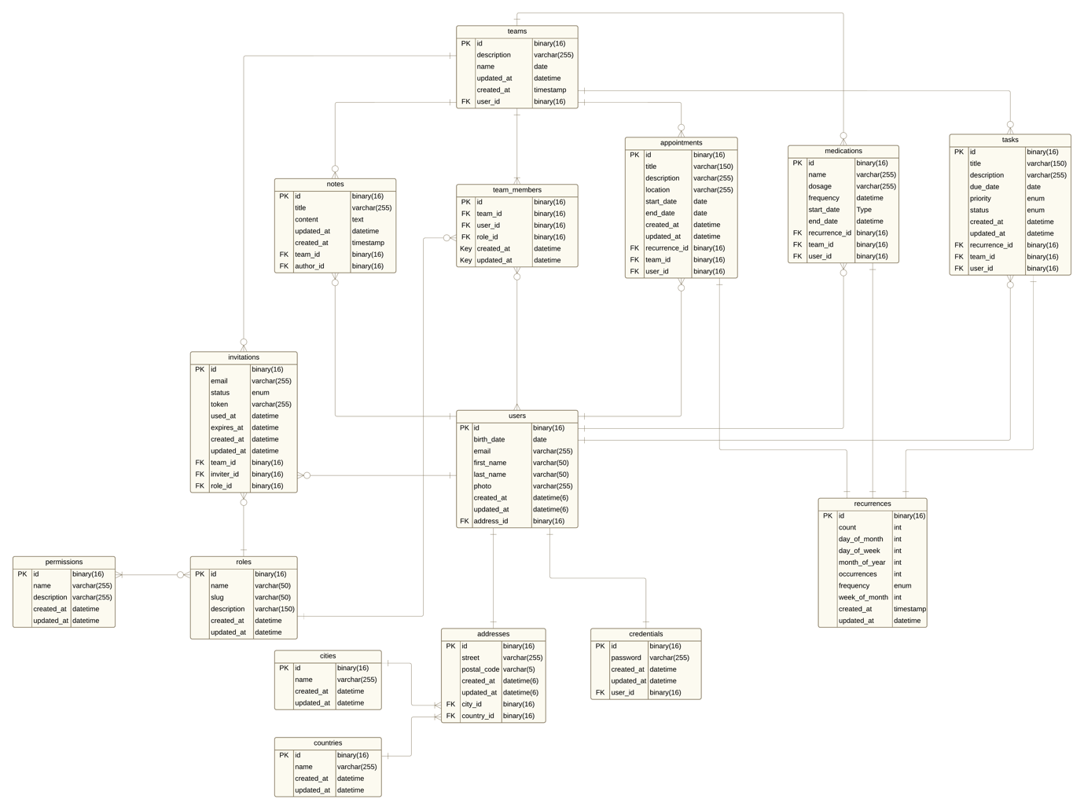

Security
- Employ end-to-end encryption for all sensitive data.

Usability
- Ensure the interface is intuitive and accessible for users with varying levels of technical proficiency.

References
- [BRD Document for Care Hub](#)
Glossary
A comprehensive list of terms and definitions used throughout the document.

